Q. no 27. Create a simple servlet used to print “HELLO WORLD”.

**Helloworld.java**

// Import required java libraries

import java.io.*;

import javax.servlet.*;

import javax.servlet.http.*;

// Extend HttpServlet class

public class HelloWorld extends HttpServlet {

private String message;

public void init() throws ServletException {

// Do required initialization

message = "Hello World";

}

public void doGet(HttpServletRequest request, HttpServletResponse response)

throws ServletException, IOException {

// Set response content type

response.setContentType("text/html");

// Actual logic goes here.

PrintWriter out = response.getWriter();

out.println("<h1>" + message + "</h1>");

}

public void destroy() {

// do nothing.

}

}

Compiling a Servlet

$ javac HelloWorld.java

If everything goes fine, above compilation would produce **HelloWorld.class** file in the same directory.

## Servlet Deployment

By default, a servlet application is located at the path <Tomcat-installationdirectory>/webapps/ROOT and the class file would reside in <Tomcat-installationdirectory>/webapps/ROOT/WEB-INF/classes.

**Web.xml**

<servlet>

<servlet-name>HelloWorld</servlet-name>

<servlet-class>HelloWorld</servlet-class>

</servlet>

<servlet-mapping>

<servlet-name>HelloWorld</servlet-name>

<url-pattern>/HelloWorld</url-pattern>

</servlet-mapping>

Above entries to be created inside <web-app>...</web-app> tags available in web.xml file. There could be various entries in this table already available, but never mind.

You are almost done, now let us start tomcat server using <Tomcat-installationdirectory>\bin\startup.bat (on Windows) or <Tomcat-installationdirectory>/bin/startup.sh (on Linux/Solaris etc.) and finally type **http://localhost:8080/HelloWorld** in the browser's address box. If everything goes fine, you would get the following result

Goto run **Helloworld.java**

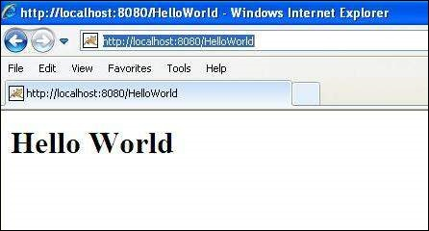

**Q.No. 28 Write a servlet that takes two numbers through the html file and prints the sum of the two numbers.**

Index.html

<!DOCTYPE html>

<html>

<body>

<form action=*"add"* method=*"post"*>

Enter 1st no <input type=*"text"* name=*"num1"*><br><br>

Enter 2nd no <input type=*"text"* name=*"num2"*><br><br>

<input type=*"submit"* ><br><br>

</form>

</body>

</html>

Web.xml

<?xml version=*"1.0"* encoding=*"UTF-8"*?>

<web-app xmlns:xsi=*"http://www.w3.org/2001/XMLSchema-instance"* xmlns=*"http://xmlns.jcp.org/xml/ns/javaee"* xsi:schemaLocation=*"http://xmlns.jcp.org/xml/ns/javaee http://xmlns.jcp.org/xml/ns/javaee/web-app_4_0.xsd"* id=*"WebApp_ID"* version=*"4.0"*>

<servlet>

<servlet-name>Demoservelet</servlet-name>

<servlet-class>servletpkg.addnum</servlet-class>

</servlet>

<servlet-mapping>

<servlet-name>Demoservelet</servlet-name>

<url-pattern>/add</url-pattern>

</servlet-mapping>

</web-app>

addnum.java

**package** servletpkg;

**import** java.io.IOException;

**import** java.io.PrintWriter;

**import** javax.servlet.http.HttpServlet;

**import** javax.servlet.http.HttpServletRequest;

**import** javax.servlet.http.HttpServletResponse;

**public** **class** addnum **extends** HttpServlet {

**public** **void** service(HttpServletRequest req,HttpServletResponse res ) **throws** IOException

{

**int** i=Integer.*parseInt*(req.getParameter("num1"));

**int** j=Integer.*parseInt*(req.getParameter("num2"));

**int** k = i + j;

//System.out.println("result is " +k);

PrintWriter out=res.getWriter();

out.println("result is" +k);

}

}

Output

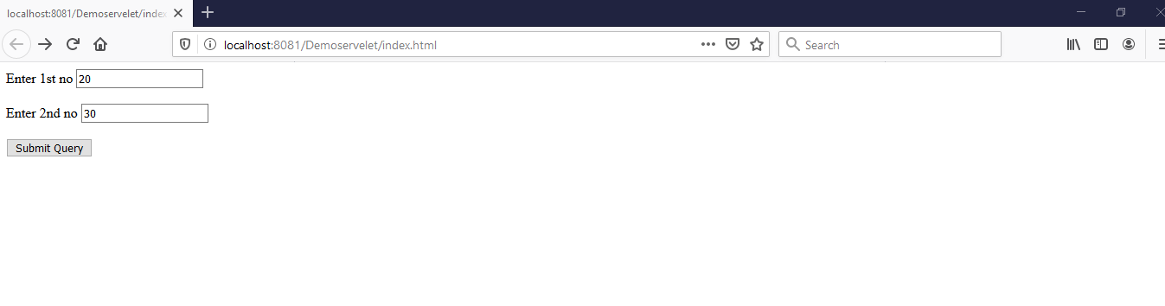

On click of submit query we get

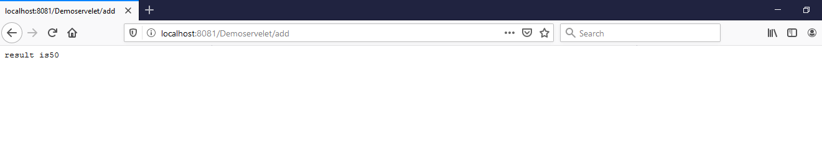

Q.No. 3 Write a servlet that takes username as input and display the username on browser .

Index1.html

<!DOCTYPE html>

<html>

<body>

<form action=*"username"* method=*"get"*>

username is <input type=*"text"* name=*"uname"*><br><br>

<input type=*"submit"* value=*"login"*><br><br>

</form>

</body>

</html>

Web.xml

<?xml version=*"1.0"* encoding=*"UTF-8"*?>

<web-app xmlns:xsi=*"http://www.w3.org/2001/XMLSchema-instance"* xmlns=*"http://xmlns.jcp.org/xml/ns/javaee"* xsi:schemaLocation=*"http://xmlns.jcp.org/xml/ns/javaee http://xmlns.jcp.org/xml/ns/javaee/web-app_4_0.xsd"* id=*"WebApp_ID"* version=*"4.0"*>

<servlet>

<servlet-name>Demoservelet</servlet-name>

<servlet-class>servletpkg.addservlet</servlet-class>

</servlet>

<servlet-mapping>

<servlet-name>Demoservelet</servlet-name>

<url-pattern>/username</url-pattern>

</servlet-mapping>

</web-app>

addservlet.java

package servletpkg;

import javax.servlet.http.*;

import javax.servlet.*;

import java.io.*;

public class addservlet extends HttpServlet{

public void doGet(HttpServletRequest req,HttpServletResponse res)

throws ServletException,IOException

{

res.setContentType("text/html");

PrintWriter pwriter=res.getWriter();

String name=req.getParameter("uname");

pwriter.println("User Details Page:");

pwriter.println("Hello "+name);

pwriter.close();

} }

Output

